5.1.3.2 Beams

The beams were largely intact with the damage typically at the ends and on the top where the floor slab had detached. Most of the beams Mr Frost saw had the end corners broken off with little damage along the beam length, as shown in Figure 63(a).

Mr Frost said that no interior beams were found with the concrete slabs still attached, as illustrated by Figure 63(b). The internal beam to floor connection is illustrated by the structural drawing section in Figure 63(c). The steel Hi-Bond flooring is discontinuous at the beams with a 60mm seating and the slab mesh passes over the top of the beam stirrups and longitudinal reinforcement. Dr Heywood indicated in red where the failure surface was typically observed. He also observed that all connections between the edge beams and floor slabs were severed. In every case the mesh and supplementary H12 reinforcement was torn from the top surface of the beam. The structural drawings specified that slab reinforcing should be placed above the beam steel. Mr Frost’s opinion was that this detailing provided poor connectivity. He would have placed some slab reinforcing underneath the top longitudinal steel to increase the connectivity between the beam and the slab.

Top of beam where slab has detached

Section from which corner has broken away

Damage to beam end

Figure 63(a): Edge beam from line 4 between lines A and B (source: Robert Heywood)

Interior beam

Hi-Bond flooring

Figure 63(b): Interior beam from the western side of the building (source: Graham Frost)

GRID

60 seating

200

200

60 seating

Typical failure surface

H12 at 120crs 4,000 long
400 alt stagger 20 cover

4-H28
200

664 mesh

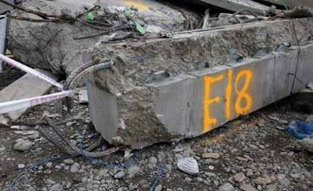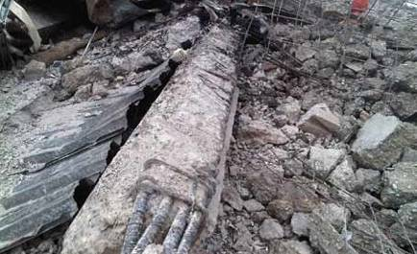

“Hi Bond” Formwork
350
Precast beam

400 column beyond

Figure 63(c): Section through precast internal beam to slab with typical observed failure surface indicated in red

Figure 63: Beam exhibits and details

5.1.3.3 Beam-column joints

Neither Mr Trowsdale nor Mr Frost saw any beam- column joints intact. Mr Frost stated that the joint regions had fallen apart as there was no steel to confine the concrete, as illustrated in Figure 64(a). Dr Heywood did not observe any interior beam-column joint where the concrete in the joint had not been lost or rendered ineffective, other than at level 6 where the columns supported the roof. The precast beam in Figure 64(b) has pulled away from the beam-column joint and is lying on its side. The photograph illustrates the smooth formed circular surface and broken off corners (or “wings”) that were a common observation with these beams.

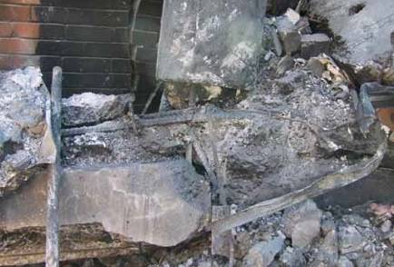Dr Heywood expressed the opinion that it was likely that the connections between the rectangular columns and the adjoining beams on the western frame on
line A (see Figure 62(a)) disintegrated during the early stages of collapse. As a result the rectangular columns detached from the building. Dr Heywood considered that if the columns had remained attached they would have suffered considerable damage and the floors would not have come to rest one above another as he observed. The end of a beam which was connected to a corner column on line A is shown in Figure 64(c). Dr Heywood described the concrete from within the beam-column joint remaining within the 90º bent bars in the beams. The beam pulled out from the column between the column reinforcement. An imprint of the vertical column reinforcement is visible in this narrow edge beam end as well as the smooth end from the precast portion. This was a poorly detailed connection, as we discuss in section 6.3.5.

Beam-column joint region

Figure 64(a): Disintegrated beam-column joint (source: Graham Frost)

Section from which the corner or “wing” has broken away

Smoothed circular surface

(b) Beam end with a smoothed circular end and bottom longitudinal reinforcement that connected to columns (source: Graham Frost)

Concrete from within beam- column joint

Smooth end of precast edge beam

Imprint of vertical reinforcing

90º bent bars

(c) End of a beam (source: Graham Frost)

Figure 64: Beam-column joint details

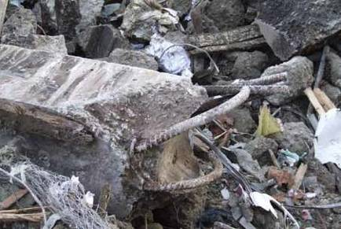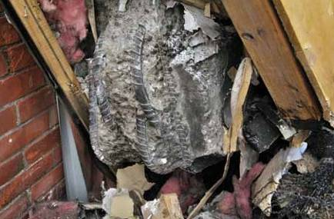When examining the remnants of the CTV building at the Burwood landfill on 28 June 2012, Dr Heywood observed a number of internal and edge beams in the rubble. All of the “wings” at the end of these beams had broken away. These wings acted as a mould for the column concrete which was cast in situ (see Figures 64(b) and 65). The semi-circular surface at the beam ends had no surface roughening and there was no evidence of any substantial bond between the beam and column concrete.
Mr Daniel Morris, who operated a concrete cutting business in the 1990s, was called as a witness by Alan Reay Consultants Limited (ARCL) and Dr Reay. Mr Morris initially gave evidence that about 200 holes had been drilled by employees of his firm in the CTV building at some point in the 1990s, about 50 of which were in beams. However, in cross-examination he conceded that his evidence was a guess which could be “wildly out”. We add that, while at the Burwood landfill, Dr Heywood looked for evidence of holes cored through the beams.

He did not find any internal or edge beams with holes cored through them. In view of his answers in cross- examination we did not consider the evidence of Mr Morris to be of any probative value.

Mr Frost, who is experienced in concrete construction, gave evidence about the weakness of the internal beam-column joints. He explained that when using precast concrete, designers should detail the construction joint to be perpendicular to the beam axis so that the compression forces can be transferred directly across the joint to limit the risk of slip along the interface. He pointed out that sloping construction joints can result in a greater spacing between stirrups, which reduces the confinement of the concrete.

Figure 65 is a diagram of the interior beam-column joint prepared by Mr Frost. This diagram illustrates the forces that could lead to the beam wings breaking off. The red arrows indicate the direction of the compression forces
from gravity loading at the bottom of the beam. The very smooth interface between the beam and column means that forces cannot be effectively transferred straight across the joint. This, together with the curved surface, generates radial forces from the column which tend to split the beam wing sections off. Since there is no reinforcing acting to confine these wings, a crack may develop as illustrated in Figure 65. Mr Frost thought it was a very strong possibility that a pulse from vertical acceleration created a force sufficient to break the wings off. He stated that, after these wings were lost, the joint would have little capacity left. The gravity and seismic shear loads on the beams would then have to be transferred through the slab, dowel action and the much reduced bearing area at the bottom of the beam. Mr Frost considered that this bearing area was a vulnerable region at the top of the column. The beam sat on the cover concrete of the column which would spall and fall away when the column was exposed to high drifts.

Approximate location of last stirrup
Typical crack location seen after collapse
Original Dwgs call for the gaps between beam ends to be sealed to prevent grout loss during insitu concrete (infill) pour. It’s not clear to me what made up the fill in these nominal 25x20 ‘rebates’ – (PEF rod/sealer/concrete)

Beam corner or ‘wing’

Compressive stresses at bottom of beam under gravity load conditions.
Centre line of column
(to balance steel tension loads)
(from -ve moment at interior beam ends)

With smooth interface between precast (log) beam
and 350Ø column infill concrete, longitudinal beam forces can’t be transferred ‘in line’ across interface. So large RADIAL forces generated. Since there were no beam stirrups detailed to be located past start
400
Precast log beam
Precast log beam
of curved end, there was nothing to confine the concrete in the
‘wings’ or resist these radial/splitting forces. 175
Vertical EQ acceleration loads would have increased the magnitude of all these forces and likely exceeded the tensile capacity
of the unreinforced concrete ‘wings’
at the end of the beams.

230 (as drawn)
(examples up to 300mm found in debris)

Outline of 400Ø
Supporting column below

Precast Log Beam

Precast Log Beam

Plan section at typical interior column
(through bottom of precast Log beams)

Figure 65: Plan view of beam-column joint prepared by Graham Frost

These observations led Mr Frost to conclude that a possible building failure mechanism was the failure of one or more beam-column joints due to a lack of confining steel in the beam ends and beam- column joints, exacerbated by the transfer of beam
compression stresses across smooth formed surfaces that were not perpendicular to the line of action of those forces.

The beam-column joints are also discussed in section 6.3.5 and sections 7 and 8 of this Volume.

5.1.3.4 Performance of the floor slabs

Mr Frost did not see any concrete floor slabs where the Hi-Bond metal decking was still attached. From this he postulated that vertical accelerations may have been great enough to lead to loss of the bond between the metal decking and the concrete slab or tension failure of the metal decking. Mr Frost stated that the metal decking had little ductility, therefore a temporary overloading force could lead to a brittle fracture of this material.

Mr Frost agreed, however, that the separation may have been due to other forces experienced during the collapse. The composite floors consist of a fairly stiff concrete element on a more flexible Hi-Bond material. These two elements could have separated when they impacted on the ground.

5.1.3.5 Disconnection of floor slabs from the walls

The concrete floor slabs came to rest leaning against the north wall complex as illustrated in Figure 66(a). Dr Heywood could identify all five edges of the suspended floor slabs in this Figure. This photograph was taken after most of the building debris had been
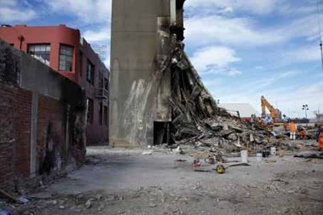removed. Mr Frost’s opinion was that the upward slope
of the floor slabs towards the north wall complex was a strong indication that the floor separated from the north wall complex later rather than earlier in the collapse sequence, see Figure 66(b). He explained that if the floor slabs had separated from the north wall complex before they lost support from the central columns, he would have expected to see the floors in a horizontal orientation or even sloping down towards the north wall complex.

Dr Heywood gave evidence that five and possibly six of the connections between each of the suspended floor slabs and the south shear wall were severed and the edges of the floor slabs came to rest relatively close to the base of the south shear wall near line 1 (Figures 69(c) and (d)). This suggested that the floors most likely detached from the south shear wall before the wall collapsed: if the floor slabs had remained attached to the south shear wall they would have been transported north with the collapsing south wall, rather than remaining at line 1. Mr Frost did not see any slabs that remained connected to the south shear wall.

Floor slabs leaning against north wall complex

Figure 66(a): Western elevation of collapsed floor slabs leaning against north wall complex
(source: Robert Heywood)

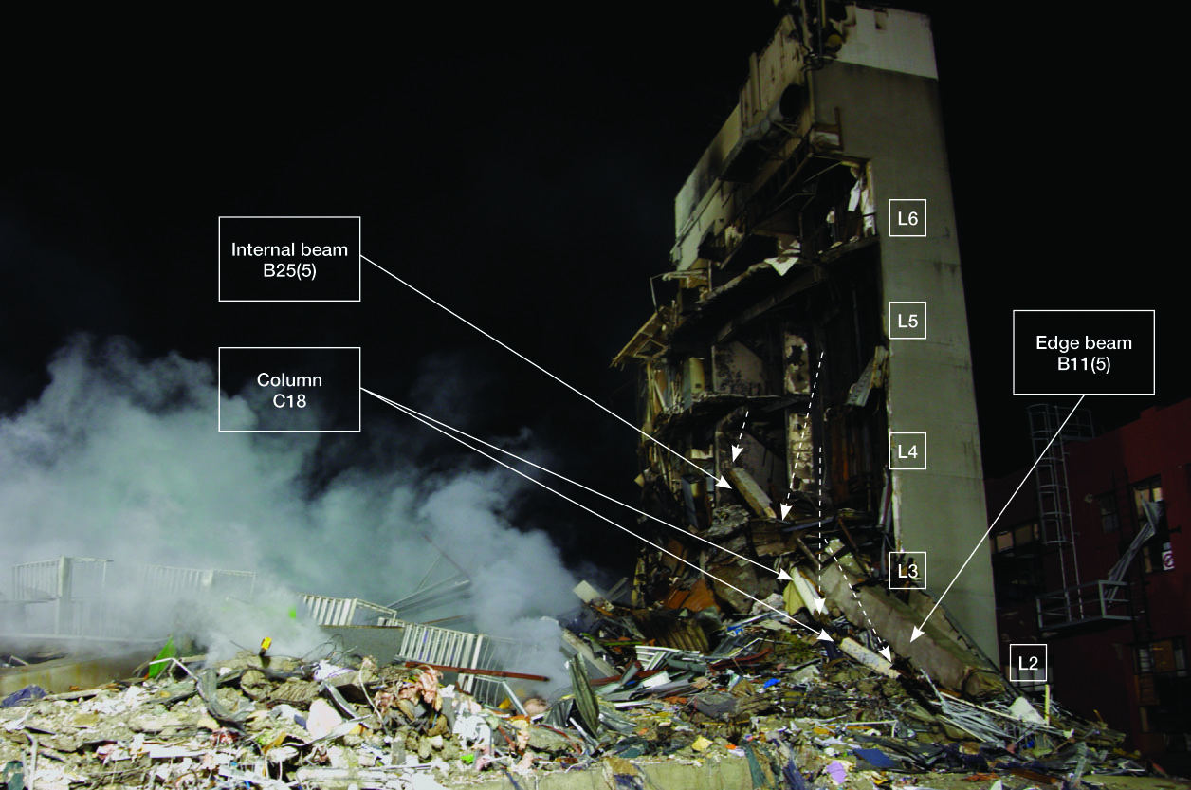

(b) Floor detachment from east side of north wall complex (source: Robert Heywood)

Figure 66: Elevations of the north wall complex

Dr Heywood also gave evidence about the detachment of the floors from the north wall complex. The detachment was complete on levels 4, 5 and 6 (Figure 67(b)), although some internal and edge beams were still attached to the north wall complex. Dr Heywood stated that in the vicinity of the amenities (the western portion of the north wall complex) the floor slab was severed 1–2m south of line 4, leaving the floor slab cantilevering from the north wall complex (see Figure 67(a)). The 664 mesh was observed to have failed in tension on the level 6 failure surface. The downward angle of the exposed mesh and the spalling of the underside of the slab are consistent with some downward movement during failure. The failure line at level 6 extended across the front of the stairs and lift wells before turning north at the eastern edge of the north wall complex. This section of the slab was subsequently removed because of safety concerns (see Figure 67(a)). On levels 4 and 5 the failure line extended across in front of the stairwell before turning into the lift well.
Dr Heywood saw drag bars installed on levels 4, 5 and
6 on both sides of the lift well walls in the north wall complex. He said that these drag bars did not prevent the slab from detaching from the north wall complex (see Figures 66(b) and 67(b)), however the drag bars still remained attached to the lift well. In some places a piece of Hi-Bond metal decking remained attached to the drag bars. The drag bars were bent downwards, which is consistent with them supporting the weight of the floor slabs during the collapse rather than the floor slabs detaching from the drag bars before the collapse. Earthquake forces would have applied principally horizontal forces to the drag bars before the collapse. Dr Heywood explained that if the earthquake forces caused separation of the floor slabs from the drag bars, he would have expected to see the drag bars virtually horizontal.

